Python Code:
def midpoint_circle(xc, yc, r):
x = 0
y = r
p = 1 - r # decision parameter
print("Circle points are:")
while x <= y:
# Print 8 points using symmetry
print(xc + x, yc + y)
print(xc - x, yc + y)
print(xc + x, yc - y)
print(xc - x, yc - y)
print(xc + y, yc + x)
print(xc - y, yc + x)
print(xc + y, yc - x)
print(xc - y, yc - x)
print("------------------")
# Update p, x, y
if p < 0:
# move right (E)
x += 1
p = p + 2*x + 3
else:
# move diagonally (SE)
p = p + 2*(x - y) + 5
y -= 1
x += 1
# Example
midpoint_circle(0, 0, 5)

output:

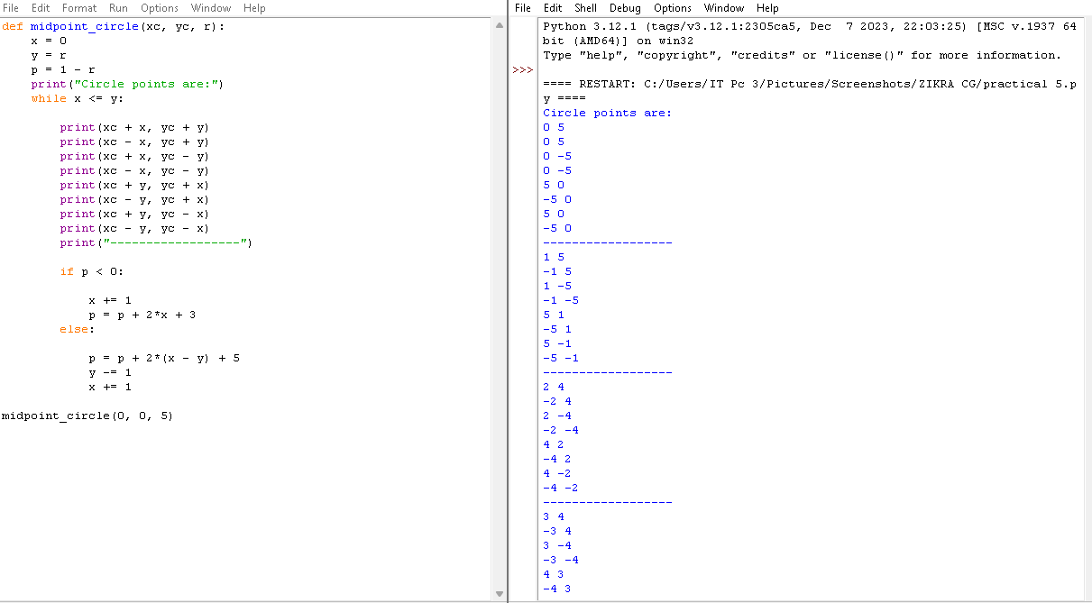
Note: Plot above points using matplotlib.
Python Code using Matplotlib:
import matplotlib.pyplot as plt
def midpoint_circle(xc, yc, r):
x = 0
y = r
p = 1 - r
X, Y = [], []

while x <= y:
# 8 symmetric points
X += [xc+x, xc-x, xc+x, xc-x, xc+y, xc-y, xc+y, xc-y]
Y += [yc+y, yc+y, yc-y, yc-y, yc+x, yc+x, yc-x, yc-x]
if p < 0:
p += 2*x + 3
x += 1

else:
p += 2*(x - y) + 5
y -= 1
x += 1
return X, Y
# Example
X, Y = midpoint_circle(0, 0, 5)
plt.scatter(X, Y)
plt.gca().set_aspect('equal')
plt.show()
output:
